SEM 1 Revision NOtes

Week 1 – classes and objects
- Class: a “template” or “blueprint”.
- Object: Something made from that “blueprint”.
  - These invoke operations called methods, and can have parameters to pass in.
  - Many instances can be created.
- Attributes: values stored in fields.
- State: what fields an object stores.

Week 2 – understanding class definitions
Mutator Methods
public void insertMoney (int amount)
{
balance = blanace + amount;
}
- [visibility modifier] [return type] [method name] [formal parameter]
{
[field being mutated]
}
String concatenation
- 4 + 5 –> 9
- “wind” + “ow” –> “window”
- “Result: “ + 6 –> “Result: 6”
- “#” + price + “cents” –> “# 500 cents”
Conditional statements
if ([boolean condition]) {
[do this if test is true]
}
else {
[do this if test is false]
}
Local variables
- Variables defined within a class are only within the scope of that class. They are local.
- They can not be accessed from outside the class.

Week 3 – Object Interaction
- Abstraction: the ability to ignore details of parts to focus attentioon on a higher level of a problem
- Modularization: the process of dividing a whole into well-defined parts.
Modulo (remainder) operator
- 17 / 5 == 3
- 17 % 5 == 2
Classes as types
- Data can be classified under many different types, like integers, boolean, floating-point.
- Furthermore, each class is a unique data type, like String.
- Data types, therefore, can be composites and not simply values
null
- A special value in Java
- All object variables are initialised to null.
- You can assign and test for null.
Method calls
- External: object.methodName(params)
- Internal: methodName(params)

Week 4 – Grouping Objects
- Many applications involve collections of objects: organisers, libraries, databases, etc.
- The number of items to be stored varies and we need to be able to apply operations to them.
Collections
- We specify:
  - The type of collection: ArrayList
  - The type of objects it will contain: <String>
private ArrayList<String> files;
“An ArrayList of String”
- ArrayList implements list functionality
- The type parameter says what we want a list of.
- We can also use diamond notation to infer the variable being assigned:
files = new ArrayList<>();
Index integers
- Using integers to index collections has a general utility:
  - Next and previous is: index +/- 1
  - Last is: list.size() - 1
Iteration – For Each loop
for (ElementType element : collection) {
loop body
}
- Statements can be nested, giving greater selectivity to the actions
- Easy to write, termination happens naturally, collection can’t be changed, no index provided.
- No index provided, can’t stop part way through, provides “definite iteration”.

Week 5 – Iterating over collections
Iteration – While loop
while (loop condition) {
loop body
}
Two approaches:
- while (this is true) {
}
- while (not (this is false)) {
}
String equality
- Do not use “==”!
- Always use .equals instead.
Iterator methods
Collections have an iterator() method. This returns an iterator object.
- Iterator<E> has methods:
  - boolean hasNext()
  - E next()
  - void remove()
Iterator<ElementType> it = myCollection.iterator();
while(it.hasNext()) {
call it.next() to get the next object
do something with that object
}
Ways to iterate over a collection
- for-each loop: use if we want to process every element
- while loop: use if we might want to stop part way through and use for repetition that doesn’t involve a collection.
- Iterator object: use if we might want to stop part way through, and used with collections where indexed access is not very efficient, or impossible.

Week 7 – more sophisticated behaviour
- Thousands of classes, tens of thousands of methods.
- Many useful classes that make life much easier, often inter-related, arranged into packages.
A competent java programmer must be able to work with libraries. It is suffice to know the interface, not the implementation.
You can find documentation of the java libraries in HTML format via the Class API.
Packages and import
import java.util.ArrayList;
import java.util.*;
Parameterised classes
The documentation includes provision for a type parameter. These tpye nmaes reappear in the parameters and return types of the methods of the class:
- ArrayList<E> –> E get(int index), boolean add(E e)
The types in the documentation are placeholders for the types we use in practice.
Random behaviour
The library class Random can be used to generate random numbers.
Import java.util.Random;
...
Random rand = new Random();
...
int num = rand.nextInt();
int value = 1 + rand.nextInt(100);
int index = rand.nextInt(list.size());
Sets
import java.util.HashSet;
HashSet<String> mySet = new HashSet<>();
mySet.add(“one”);
mySet.add(“two”);
mySet.add(“three”);
for(String element: mySet) {
do something with element
}
Tokenising Strings
public HashSet<String> getInput()
{
System.out.print(“> “);
String inputLine = reader.nextLine().trim().toLowerCase();
String[] wordArray = inputLine.split(“ “);
// add words from array into hashset
HashSet<String> words = new HashSet<>;
for (String word: wordArray) {
words.add(word);
}
return words;
}
Maps
- A map with strings as keys and values.
HashMap <String, String> contacts = new HashMap<>();
contacts.put("Verbal Kint", "(531) 9392 4587");
contacts.put("Kobayashi", "(402) 4536 4674");
contacts.put("Kaiser Soze", "(998) 5488 0123");
String number = contacts.get(“Verbal Kint”);
System.out.println(number);
Collections and Primitive Types
- The generic collection classes can be used with all class types, but what about primitive types?
- Primitive types are not object types. Primitive-type values must be wrapped in objects to be stored in a collection!
- Wrapper classes exist for all primitive types.
Documenting classes
- Documentation of a class should include:
  - The class name
  - A comment describing the overall puirpose and characteristics of the class
  - A version number
  - The authors’ names
  - Documentation for each constructor and each method
- The documentation for each constructor and method should include:
  - The name of the method
  - The return type
  - The parameter names and types
  - A description of the purpose and function of the method
  - A description of each parameter
  - A description of the value returned
Public vs Private
Only methods that are inteded for other classes should be public.
Information hiding
Data belonging to one object is hidden from other objects. Information hiding increases the level of independence.
Constants
A variable, once set, can have its value fixed by designating the final keyword.
final int SIZE = 10
- Static: class variable
- Final: constant

Week 8 – Designing Classes
- Software is extended, corrected, maintained, ported, adapted.
- It either changes continuously, or it dies.
Coupling
- Refers to links between separate units of a program.
- If two classes depend closely on many details of each other, we say they are tightly coupled.
- We aim for loose coupling.
  - Encapsulation supports loose coupling
    - Private elements cannot be referenced from outside of the class.
    - Reduces the impact of internal changes
  - Responsibility-driven design supports loose coupling
    - Driven by data location
    - Enhanced by encapsulation
Cohesion
- Refers to the number and diversity of tasks that a single unit is responsible for.
- If each unit is responsible for one single logical task, we say it has high cohesion.
- We aim for high cohesion
  - Makes it easier to:
    - Understand what a class or method does
    - Use descriptive names for variables, methods and classes
    - Reuse classes and methods
- Cohesion can be at different levels
  - Class level:
    - Classes should represent one single, well defined entity
  - Method level:
    - A method should be responsible for one and only one well defined task.
  - Module/Package level:
    - Groups of related classes.
Implicit coupling
- Linkage not necessarily expressed via data and method interactions.
- Can arise from assumptions about the way a class is implementing
- Satisfactory resolution might require a small increase in explicit coupling.
Thinking ahead
- Code duplication is an indicator of bad design. It makes maintenance harder and can lead to the introduction of inconsistencies and errors during maintenance/modification.
- When designing a class, try to think about changes likely to be made in the future. Aim to make those changes easy.
Refactoring and testing
- When classes are maintained, code is usually added.
- Classes and methods tend to become longer.
- Every now and then, classes and methods should be refactored to maintain cohesion and low coupling.
- When refactoring code, separate the refactoring from making other changes.
  - First do the refactoring only, without changing the funcitonality
  - Test before and after refactoring to ensure that nothing was broken.
Design guidelines
- A method is too long if it does more than one logical task.
- A class is too complex if it represents more than one logical entity.
Enum types
public enum CommandWord
{
// A value for each command word, plus
// one for unrecognised commands.
GO, QUIT, HELP, UNKNOWN;
}
- Each name represent an object of the enum type, e.g., CommandWord.HELP.
- Enum objects aren ot created directly.
- Enum definitions can also have fields, constructors and methods.

Week 9 – Fixed Size Collections
Arrays
- Fixed in length
- Use a special syntax
- Objects with no methods
Sometimes the maximum collection size can be pre-determined. A special fixed-size collection type is available: an array.
Unlike the flexibile List collections, arrays can store object references or primitive-type values (without autoboxing).
private int[] hourCounts;
hourCounts = new int[24];
Afterwards, we assign according to the index:
hourCounts[0] = 0;
hourCounts[3] = 3;
We can also declare them as literals, where the size is inferred from the data.
private int[] numbers = {3, 15, 4, 5};
They can only be used in declarations. Related uses require new:
Array-related methods
- binarySearch
- fill
- sort
ArrayList has toArray
Iteration – For loop
for (initialization; condition; post-body action) {
statements to be repeated
}
e.g.:
for(int hour = 0; hour < hourCounts.length; hour++) {
System.out.println(hour + “: “ + hourCounts[hour]);
}
with Iterator:
for(Iterator<Track> it = tracks.iterator(); it.hasNext(); ) {
Track track = it.next();
if(track.getArtist().equals(artist)) {
it.remove();
}
}
Arrays of more than one dimension
Array syntax supports multiple dimensions – think array of arrays.

Week 10 – Functional processing of collections
Functional programming:
- Code can be treated as data.
- Segments of code can be stored in variables, passed as parameters, etc.
e.g.:
loop (for each element in the collection):
get one element;
do something with the element;
end loop
–>
collection.doThisForEachElement(some code);
Methods v.s. Lambdas
- Method
public void printSighting(Sighting record)
{
System.out.println(record.getDetails());
}
- Lambda
(Sighting record) ->
{
System.out.println(record.getDetails());
}
  - No visibility keyword (assumed as public)
  - No return type: return type is inferred
  - No name
  - An arrow separates the parameter list from the body

foreach method
sightings.forEach(
(Sighting record) ->
{
System.out.println(record.getDetails());
}
);
- A lambda starts with a list of parameters;
- An arrow symbol follows the parameters;
- Statements to be executed follow the arrow symbol
Syntax varations
There are various abbreviations we are allowed to use, and it gets interesting when we make use of those:
- Leave out the parameter type
- Leave out the brackets
- Write into one line
sightings.forEach(s -> System.out.println(s.getDetails()));
Streams
Streams are similar to collections but with some important differences:
- Accessed sequentially (not by index)
- Contents of the stream cannot be changed (but a new stream can be created)
- A stream can be infinite
These are used to unify processing of data streams: collections, data received from network, lines from a file, etc. They are sequences of data items to be processed, potentially concurrently.
Collections are not streams, but can be made a stream using the stream method:
myList.stream();
Filter, map, reduce
Many different kinds of processing can be achieved with combinations and variations of three functions:
filter / map / reduce
- Filter selects some elements, creates an ew stream with selected elements where some elements are filtered out.
- Map maps the original stream to a new stream, and each element is replaced by a different one, derived from the original
- Reduce collapses a stream into a single result, like the sum, selecting the minimum, etc. You always end up with a single value.
- We can then use pipelines to combine streams.
Streams meet Lambdas in Java
- Filter
  - Require a boolean lambda (predicate) as a parameter.
  - e.g. printing all sightings of a particular animal
public void printSightingsOf(String animal)
{
sightings.stream()
.filter(s -> animal.equals(s.getAnimal()))
.forEach(s -> System.out.println(s.getDetails()));
}

- Map
  - Creates a new stream with new object, possibly of different type.
  - e.g. extracting just the details String from a Sighting
sightings.stream()
.map(sighting -> sighting.getDetails())
.forEach(details -> System.out.println(details));
- Reduce
  - Takes two parameters: a value and a lambda:
reduce(start, (acc, element) -> acc + element)
  - The lambda parameter itself takes two parameters:
    - An accumulating value for the final result
    - An element of the stream
  - The lambda determines how to merge an element with the accumulating value.
  - The lambda’s reslt will be used as the acc parameter for the next element
  - The start value is used as the first acc parameter that is paired with the first element
  - e.g. counting animals
return sightings.stream()
.filter(s -> animals.equals(s.getAnimal()))
.map(s -> s.getCount())
.reduce(0, (total, count) -> total + count);
  - Reduce has two parameters: the first is 0, the second is a lambda.
  - The lambda itself has two parameters (total and count).

Remove If
Remove from the sightings list all of those records with a count of zero.
sightings.removeIf(sighting -> sighting.getCount() == 0);
Method References
Comparison: passing a method name
sightings.stream()
. …
.forEach(d -> System.out.println(d));

sightings.stream()
. …
.forEach(System.out::println);

- Convenient shorthand
- Often used where the compiler can work out the full method call
- Written with ::
- Examples:
  - Reference to a static method
    - Static method (one parameter)
    - Applied to stream elements
x -> Math.abs(x) → Math::abs

  - Reference to a method call on a particular object
    - Method of a static object (one parameter)
    - Applied to stream elements
str -> System.out.println(str) → System.out::println
  - Reference to an instance method of a given type
    - Instance method (no parameter)
    - Applied to stream elements
str -> str.length() → String::length
  - Reference to a constructor
    - Strictly speasking, a constructor is not a method
    - Rarely used
() -> new ArrayList<>() → ArrayList::new

Week 11 – Well Behaved Objects
- Early errors are usually syntax errors.
- Later errors are usually logic errors.
  - Some logical errors have no immediately obvious manifestation.
Prevention vs Detection
We can lessen the likelihood of errors:
- Use software engineering techniques, like encapsulation
- Pay attention to cohesion and coupling.
We can improve the chances of detection
- Use software engineering practices, like modularisation and good documentation.
- We can develop detection skills.
Testing and debugging
These are crucial skills.
- Testing searches for the presence of errors.
- Debugging searches for the source of errors.
Testing fundamentals:
- Understand what the unit should do – its contract
- Test things that should work and shouldn’t work
- Understand the boundaries – zero, one, full
- Blackbox vs Whitebox testing
Unit Testing
Each unit of an application may be tested.
- Method, class, module
Can (should) be done during development
- Finding and fixing early lowers development costs (e.g. programmer time)

Unit Testing with BlueJ
- Objects of invidual classes can be created.
- Individual methods can be invoked.
- Inspectors provide an up-to-date view of an object’s state.
Test Automation
Good testing is a creative process, but thorough testing is time consuming and repetitive.
- Regression testing involves re-running tests.
- Use of a test rig can relieve some of the burden.
Test harness
- Additional test classes are written to automate the testing.
- Objects of the harness classes replace human interactivity.
- Creativity and imagination required to create these test classes.
- Test classes must be kept up to date as functionality is added.
- Test frameworks exist to support automation.
JUnit
- A Java test framework
- Test cases are methods that contain tests
- Test classes contain test methods
- Assertions are used to assert expected method results
- Fixtures are used to support multiple tests
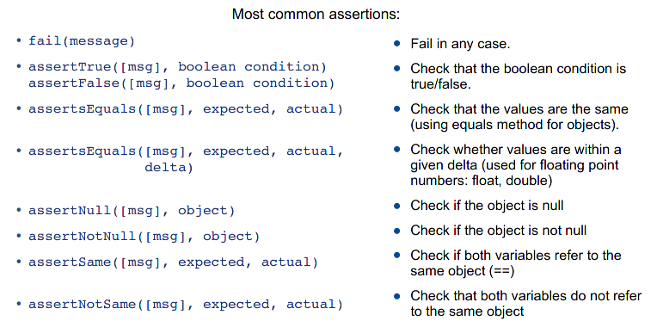

Test Fixtures
Many tests require a starting state to be able to run
- Setting up the state in each test can be tedious, and can result in code duplication
- The solution is a “test fixture”.
- A test fixture is a set of object in a predtermined state used to run one or more tests.
- Test fixtures are created using ad edicated JUnit annotations.
To create the fixture:
@Before
public void setUp() {
…
}
To clean up afterwards:
@After
public void tearDown() {
…
}
- The @Before method is run before every test.
- The @After method is run after every test.
- Every test starts with a frest set of (the same) objects (objects in the same state).
- Also @BeforeClass and @AfterClass.
- Run before/after the test class is run.
- Used to perform expensive intialisations (e.g. Database setup, network initilisations)
- Tests are not independent!
Annotations
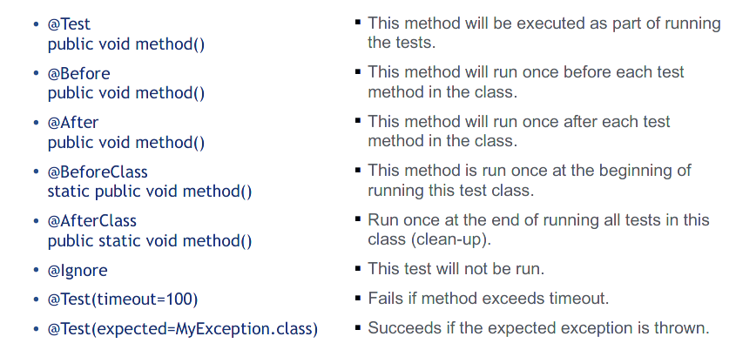

Exception Handling
Expecting an exception in a test:
@Test(expected=FileNotFoundException.class)
public void testClear() {
…
}
The test will succeed if an exception of the expected class is thrown; otherwise it behaves as before (may pass or fail depending on assertions in the test)
@Test(timeout=1000)
public void testClear() {
…
}
The test will fail if the execution takes more than 1000 milliseconds
Test driven development
- When should you write your tests?
  - XP proponents argue: before writing the code
- Tests serve as specifications
- Initially, all tests fail
- When all tests pass, you’re done
- What to do when a defect is reported?
  - Make a test for it.
  - Make it a pass.

